**inhousing and Stretchy Tech Plan**



**Our purpose** is to improve the lives of people with disability by

* giving them good quality homes
* using inclusive technology.



**Our values** are for people with disability to

* have choice and control in their own lives
* 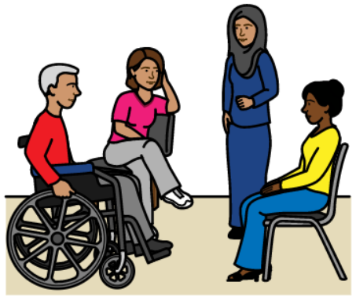be active members in their community
* improve their skills and abilities.

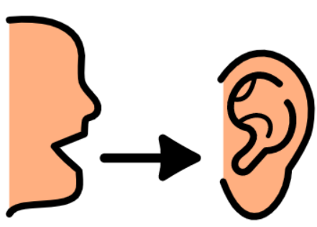The following are our key areas of focus.

1. **Listen to the needs of our tenants.**

A **tenant** is the person who lives in the house we provided.

We give our tenants choice and control over their housing. We respect them as decision makers in their own lives.

By listening to them we can improve

* the community
* government policies.

1. **Quality homes**

We want our tenants to choose

* what home they want to live in
* what their home looks like
* who they want to live with.

1. **Community connection**

We help our tenants connect to the community around their home.

1. **Improving our work**

To make sure our organisation is as good as it can be we:

* use the right technology to make sure our cyber security is strong
* tell people about our brand and values
* focus on every detail so that we can give all our tenants a very high-quality service
* make sure our workplace includes everyone and helps them to learn and grow.

1. **Improving the future**

We lead the way in inclusive housing.



We offer smart and eco-friendly homes that meet the unique needs of our tenants.



Our homes

* include technology that improves the lives of our tenants
* reduce the costs of daily living.