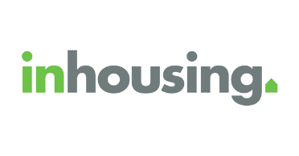**inhousing News (Easy English)**

This is the inhousing newsletter for Summer 2024-25.

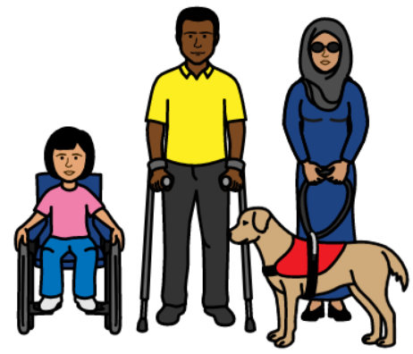Happy International Day of People with Disability!

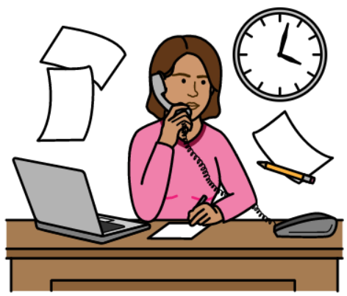

It has been a busy 2024.

We gave out the 2024-27 inhousing Strategic Plan.

We will talk about the Plan in this newsletter.

**2024-27 inhousing Strategic Plan**

This is our plan for the future.

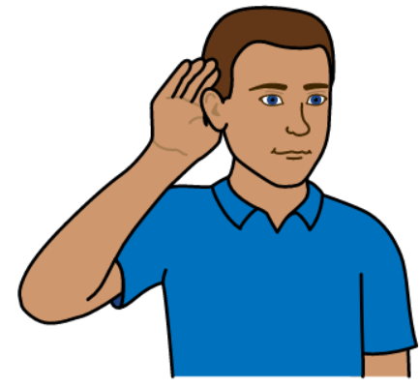We are working on:

* listening to you and what you want
* 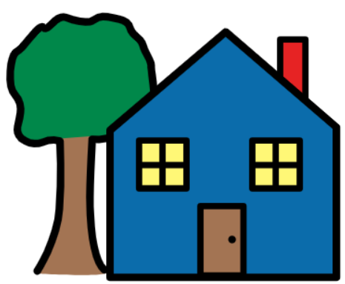improving your housing
* making your house more affordable and accessible
* 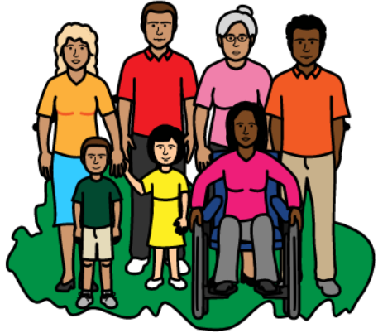connecting you with the community

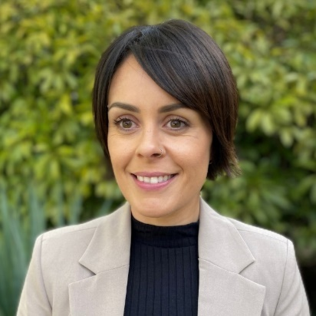**Meet Carlee**

Carlee is a team leader. She joined inhousing in July 2024.



She is passionate about what she does. She has a disability so her work is very important. Carlee loves helping people feel safe, empowered and valued.

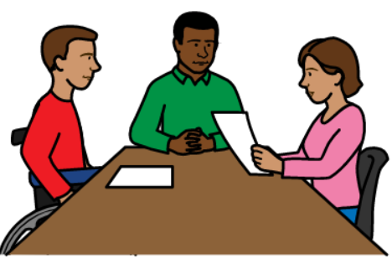Carlee’s role is to

* support her team
* help tenants with their housing
* help tenants be more included in their community

A **tenant** is a person who lives in the house we gave them.

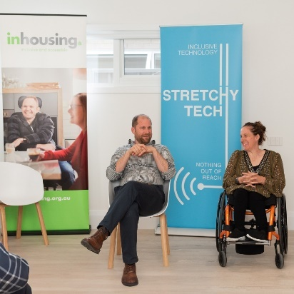**Hanna**

Hanna is an inhousing tenant. We had a chat to her about her home.

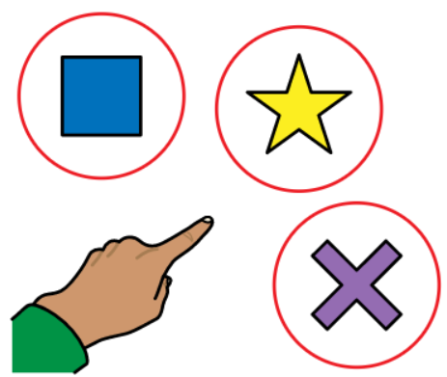

Hanna said it was incredible that she was so involved. She had choice and control.

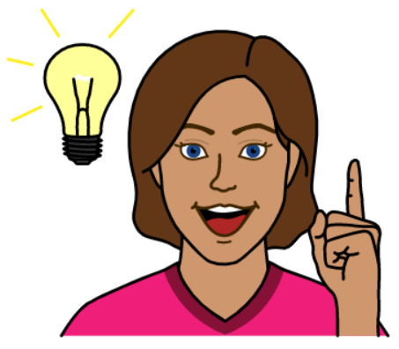She gave inhousing ideas for improving her home.

Her home was made to be accessible for her.

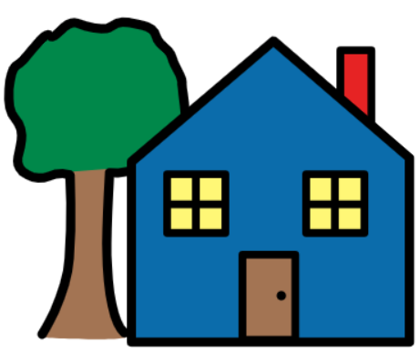**Are you able to get** **Specialist Disability Accommodation (SDA)?**

SDA is housing for people with disabilities.

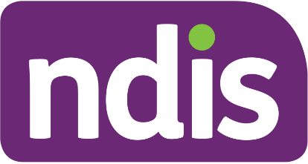

You can only get it if you are a NDIS participant.



Some people with disabilities can get SDA but some can not.

To find out if you can get SDA go to:

https://inhousing.org.au/news-resources/housing-information-service

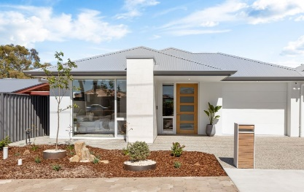**Vacancy: Floriedale Road, Greenacres**

We have a house that is vacant!

**Vacant** means that no one is living in that house yet.

It is at Greenacres.

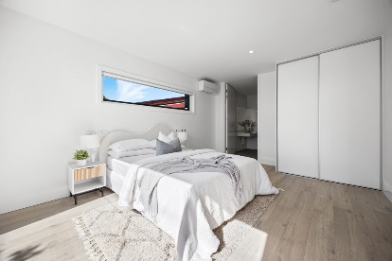This house has

* flat entrances
* wide pathways and doors
* accessible carpark
* accessible bathroom
* air conditioning and heating
* automated blinds, windows, lights and benchtops
* energy efficient design

You can see more details by going to:

<https://inhousing.org.au/services/rent-us/new-sda-home-greenacres-spacious-and-accessible-living>

**Stretchy Tech: LED lights**

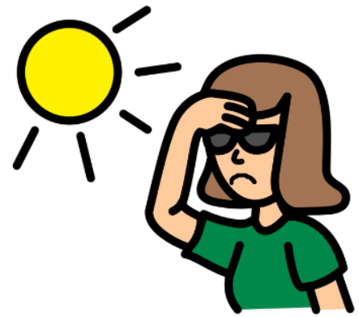Some people have

* light sensitivity
* sensory processing disorder

These people can struggle with regular lights.

LED lights can be better for these people.

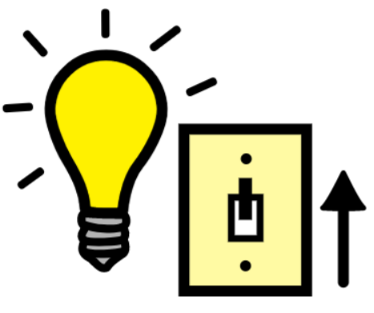LED lights can be

* dimmable (you can make it brighter or darker)
* warm or cool coloured

Stretchy Tech works with clients to find the best lighting for them.



We hope you enjoyed this newsletter!