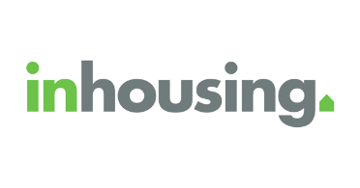**inhousing News (Easy English)**

This is the inhousing newsletter for Spring 2024.

Welcome to our first newsletter!

We did a survey to find out the topics that matter to our **tenants**. A **tenant** is the person who lives in the inhousing home.

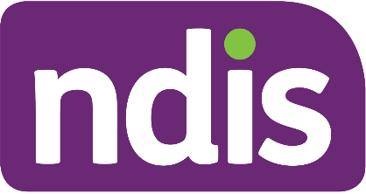The topics that tenants want to know about are:

* NDIS and housing supports
* Stories about our community
* Accessible housing
* Home organisation
* Assistive technology
* Puzzles and games
* Delicious recipes, and
* Ways to engage more in the community.

Our newsletters will cover these topics.

If you have a story idea or want to give feedback about our newsletter, you can email us:  [property@inhousing.org.au](mailto:property@inhousing.org.au?subject=Newsletter%20suggestion)

**What is inhousing?**

inhousing gives people with disabilities great housing.

inhousing started in 1999.

We believe that good homes and easy-to-use technology improve the lives of people with disabilities.

Follow us on social media!

[Facebook](https://www.facebook.com/inhousingandstretchytech/)



[Instagram](https://www.instagram.com/inhousing_stretchytech/)

[LinkedIn](https://www.linkedin.com/company/inhousing)

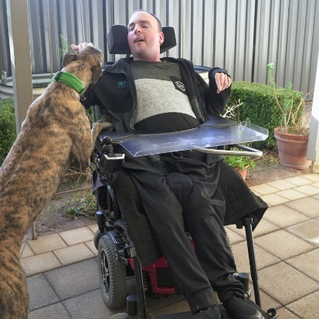**Craig’s journey from house to home**

Craig used to live in a group home. He did not have much independence. He was not able to make many of his own choices.

Through NDIS, Craig was able to get an inhousing home. Criag is now able to live more independently!

**Housing Information Service (HIS) by inhousing**

We have made a new online service called Housing Information Service (HIS).

This service gives important information about inclusive and accessible housing.

To find out more: [Housing Information Service](https://inhousing.org.au/news-resources/housing-information-service)

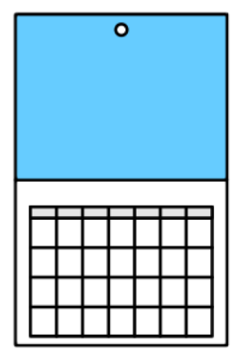**Rent reviews and Commonwealth Rent Assistance**

We will have our twice-yearly rent reviews in October 2024.



We will ask you about your **income**. **Income** is how much money you make.

If we already have permission from Centrelink to get this information, then we will not need to ask you.



Commonwealth Rent Assistance (CRA) can help you pay rent. You may be able to get this if you get payments from Centrelink.

You need to keep Centrelink updated about your living situation and income.

This will ensure you get paid the right CRA amount.

To find out more: [Rent Assistance](https://www.servicesaustralia.gov.au/rent-assistance)

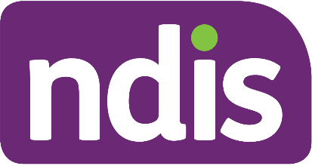**Facebook housing forum for NDIS participants**

Are you an NDIS Participant who is going through a change in your housing?



There is a new Facebook forum called **NDIS Housing Peer Support Group**.

You can get support from others online.

To visit the forum, go to: [NDIS Housing Peer Support Group](https://www.facebook.com/groups/hhpsg/)

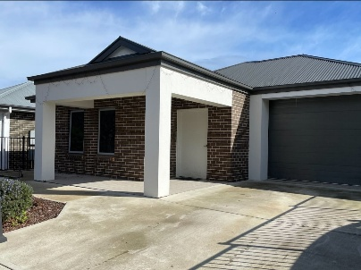**There is a house available at Kelly Grove, Mitchell Park**

It is a 2-bedroom home.

The home has

* An accessible bathroom
* Wide pathways and door frames
* Automatic doors
* 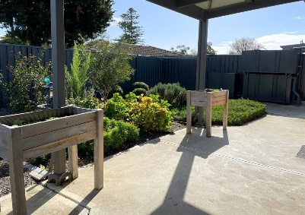Ceiling hoist
* Secure backyard
* Outdoor living/entertaining area

To find out more: [Mitchell Park Home](https://inhousing.org.au/services/rent-us/kelly-grove-mitchell-park)

**Stretchy Tech's top tips: Android captions**

You can get live captions on Android phones!

You can get live captions for

* Videos
* Podcasts
* Phone calls
* Video calls
* Audio messages

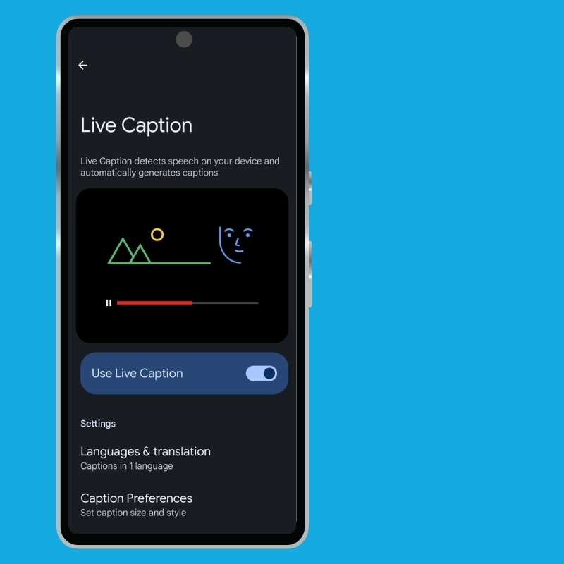To get live captions:

Open **Settings**

Tap **Accessibility**

Toggle **Live Caption** to the right

To find out more: [Live Captions](https://support.google.com/accessibility/android/answer/9350862?hl=en&mc_cid=463081b038&mc_eid=b7cf4b0fd6#turn_on_live_caption)

We hope you enjoyed our newsletter!