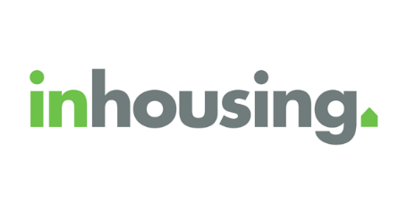**inhousing news: Winter 2025**

This is the inhousing news for Winter.

It is getting cold! Stay warm, everyone!



**Help design your future home in Mitchell Park**

We are building 3 new homes in Mitchell Park.

The homes will be for people with disabilities.



We want future tenants to help design the homes!

You can be part of this if you

* are a NDIS participant

and

* have high support needs.

To find out more or say you want to be a part of this

Email: [property@inhousing.org.au](mailto:property@inhousing.org.au?subject=EOI%3A%20Mitchell%20Park%20SDA%20home%20design)

Or

Phone: 8373 8318

**Share your feedback and you could win!**

Your feedback helps inhousing do better.

We want you to take part in our 2025 Tenant Survey.

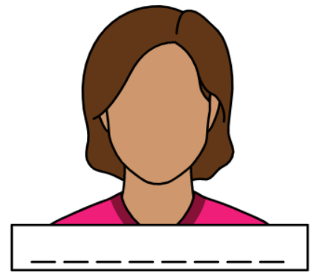The survey will be short and you do not have to tell us your name.

You can tell us what we are doing well and what we could do better.



If you do the survey, you could win a Coles/Myer Group gift card.

To find out more: <https://inhousing.org.au/news-resources/news/tenant-survey-we-want-hear-what-you-think>

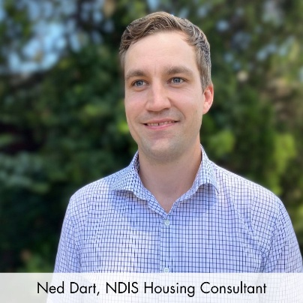**Meet Ned**

Ned is a NDIS housing consultant. This means he works with customers and their families to find housing that meets their needs.

He joined inhousing in October 2023.

He is passionate about helping people with disabilities find the right home.

**Maintenance and repairs**

If something in your inhousing home needs to be checked or fixed:

* Email: maintenance@inhousing.org.au
* Call: (08) 8373 8318
* Go to: https://inhousing.org.au/tenant-information/report-repair

If it needs to be fixed very quickly, call our Emergency Maintenance line on (08) 8373 8305.

**Be part of our mailing list**

Check out the homes we have on offer here: <https://mailchi.mp/3fc494011e9d/inhousing-property-update-feb-2025>

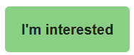If you see a home that is right for you, click ‘I’m interested’ to find out more.

Want to be told when there is a new house on offer? Join our mailing list: <https://inhousing.org.au/contact-us/newsletter>

**Stretchy Tech news**

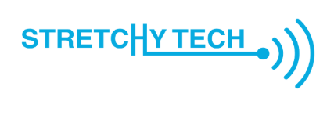Have you seen our AT Solutions Hub yet?

It is an online platform where we share how assistive technology can help people.

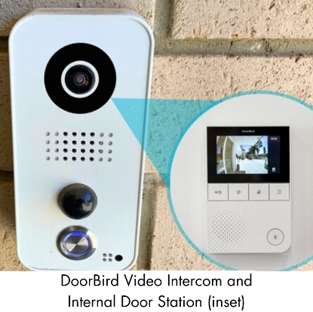For example, this is a doorbell that is controlled by an app.

It helps Tatiana, a Stretchy Tech customer with Rheumatoid Arthritis.



It is an easier way for her to see and control her front door.

To find out more: https://stretchytech.org.au/solutions-hub/automation-opens-door-possibilities

**Purple Orange: General Purpose Distribution Fund**

There is a fund called the Purple Orange General Purpose Distribution Fund.

It helps pay for smart devices for people to use as assistive technology.

You might be able to get a smart device if

* You are over 18
* You do not earn much money
* You are South Australian

and

* You have one of the following disabilities: acquired brain injury, degenerative neurological condition or a certain type of physical disability

To find out more: <https://purpleorange.org.au/what-we-do/our-grants#GeneralPurposeDistributionFund>



We hope you liked our Winter inhousing news!