
inhousing News


Spring 2026


Easy English

This is inhousing news for Spring 2026!

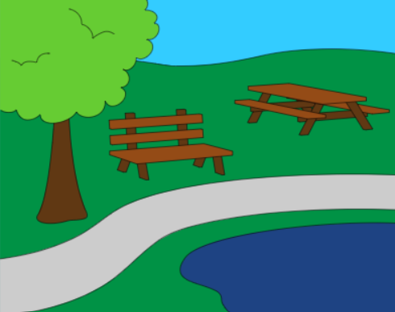
Spencer Street Reserve
We had a Christmas picnic last year at the Spencer Street Reserve.
There were some accessibility issues at the Reserve.
Accessibility issues are things that make it hard for people with disability to use.

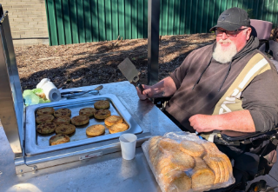
An inhousing tenant who uses a wheelchair was at the Christmas picnic.
His name is Mark.

Mark gave us feedback on things that make it hard for people with disability to use the Reserve.


inhousing staff and the Campbelltown City Council worked together to make the reserve easier to use for people with disability.


Do you have a great story like this one?
We would love to hear about it!
Email media@juliafarr.org.au

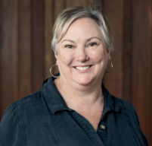
Meet Sam
Sam is the inhousing Maintenance Officer.
She helps tenants get things fixed in their homes.

She helps keep inhousing homes safe and comfortable.
Sam says the best part of her role is the team around her.

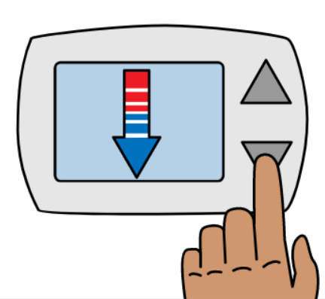
Tips on using your air-conditioner
To keep comfortable and save on your power bill
- close doors, windows and curtains
- only cool the rooms you are using
- turn it on before your home becomes too hot
- clean filters every 1 to 3 months
- keep outdoor units clear of leaves and dirt.


Set the right temperature
Summer: 24–26°C
Winter: 18–20°C
Setting it colder will not cool the house faster.
It will just use more electricity.


Changing the filter on your air conditioner helps keep it working.
If you have changed the filter and your air conditioner still has a problem, tell us as soon as you can.
If you need something checked or fixed in your house, you can
Email maintenance@inhousing.org.au
Call (08) 8373 8318
Go to our website inhousing.org.au/tenant-information/report-repair
If you need to contact us outside of work hours, you can call (08) 8373 8305.
There may be a fee if you call us outside of work hours.


Stretchy Tech
Apple has made changes to devices so that people with disability can use them more easily.
It is called the iOS 26 update.


It helps people with disability by
- making words easier to read
- making captions better
- allowing the person to use the device without needing to touch it


To find out more, go to
https://stretchytech.org.au/stories/blog/ios-26-whats-new-and-what-it-means-accessibility
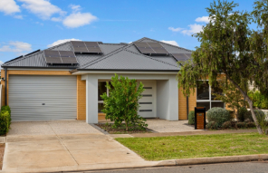
House in Salisbury
There is a house available in Salisbury.
It has 2 bedrooms and 2 bathrooms.

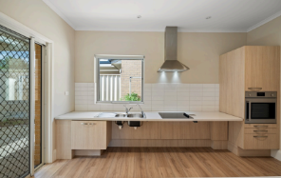
It is for someone who needs lots of physical support.
The house has
- grab rails in the main bathroom
- automatic blinds and windows.
If you are interested you can
Email intake@inhousing.org.au

or
Phone 8373 8318


To find out more information about the house
https://inhousing.org.au/services/rent-us/one-two-vacant-neighbouring-single-occupancy-villas-salisbury

To see other houses that are available
https://inhousing.org.au/services/rent-us

