
inhousing News


Winter 2026


Easy English

This is inhousing’s Winter News.

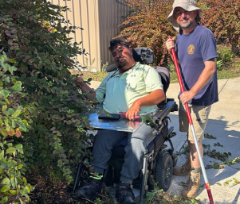
Meet Corey
Corey lives in an inhousing home.
He loves gardening.
He enjoys keeping his garden looking great!


It is good for tenants to make their houses feel like homes.
A tenant is the person who lives in the inhousing home.


You can share with us how you do this.
We would love to hear from you!
You can email us and send photos to media@juliafarr.org.au


Meet Kate
Kate works at inhousing.
She joined the team in March of this year.


She is the Tenancy and Property Coordinator.
She helps tenants settle into their new homes.

What she loves most about her work is connecting with tenants.


How can I decorate my home when I rent?
Tenants need to be careful when decorating their homes.
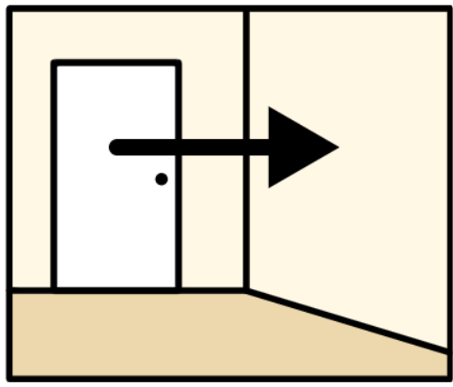
They need to make sure their decorations do not
- cause damage
or
- leave marks behind.

Here are some ways you can safely decorate.
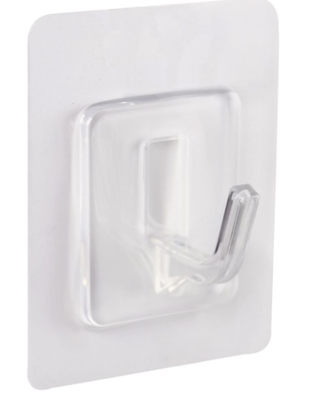
If you want to hang something on the wall, you can
- use temporary hooks or tape that do not damage the paint.


Add decorations that can be easily moved, like
- rugs


- fun storage displays
- photo frames and décor that can be placed on tables and cupboards
- plants.


New inhousing homes coming in 2027
There will be 5 new inhousing homes in Mitchell Park.
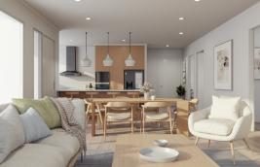
3 of these homes are for people with high physical support needs.
There are 2 bedrooms and 2 bathrooms in each home.

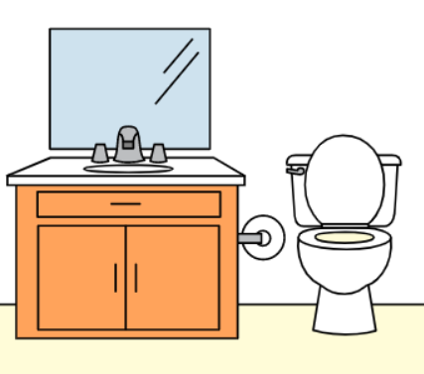
The homes will have
- accessible bathrooms
- wide doorways and pathways
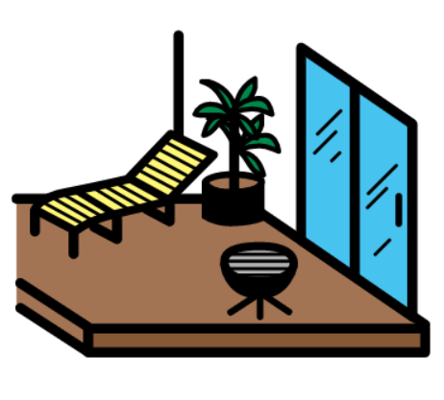
- an outdoor deck
- an undercover carpark.
To find out more information, go to
https://inhousing.org.au/services/rent-us/coming-2027-new-sda-homes-mitchell-park

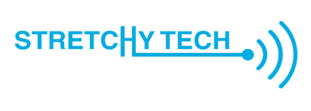
Stretchy Tech
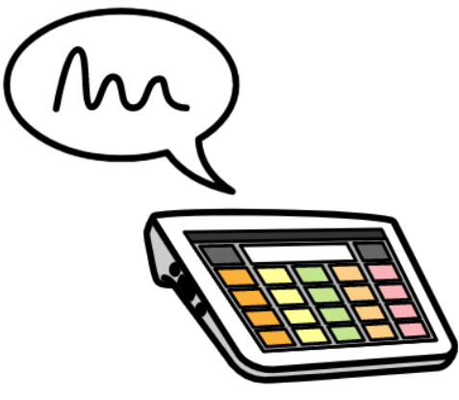
We have a team that works with us called Stretchy Tech.
They give people with disability technology that helps them in everyday life.

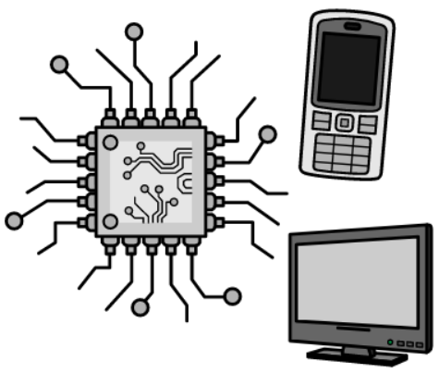
It helps them around their homes.
If you want to learn more about this, you can
- Phone 1300 043 837
or
- Go to www.stretchytech.org.au

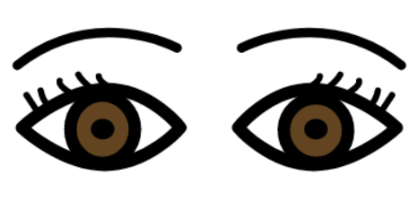
Using technology with just your eyes
Some people with disability may not be able to touch a screen or device to use it.
They may not be able to use voice control either.


Eye gaze technology is when someone controls a device using just their eyes.

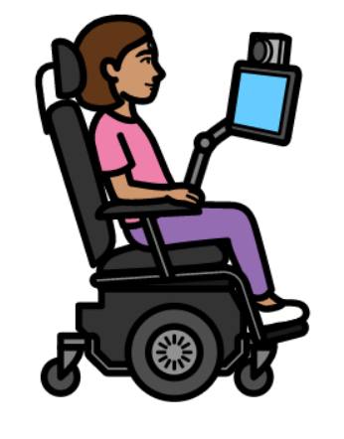
This can be really helpful for people with disability.
It is another way for people to have access.

To find out more about different ways technology can help people, go to
stretchytech.org.au/inclusive-technology/solutions

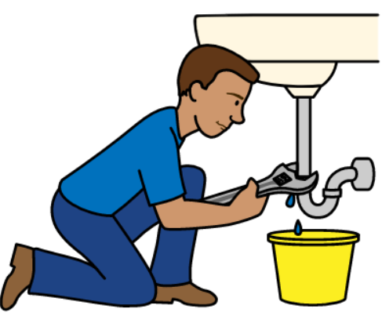
General Maintenance and Repairs
Just a reminder that if you need maintenance or repairs in your home:
- Email maintenance@inhousing.org.au
- Call (08) 8373 8318
- Go to inhousing.org.au/tenant-information/report-repair

